20.31: a) 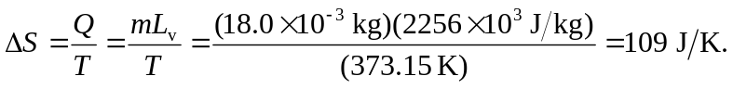
b) 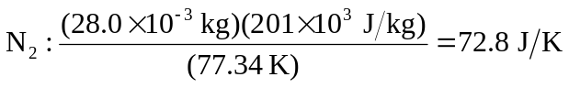

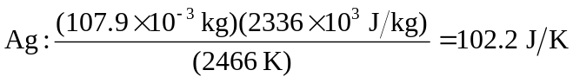

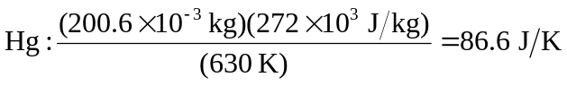

c) The results are the same order or magnitude, all around 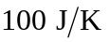 .The entropy change is a measure of the increase in randomness when a certain number (one mole) goes from the liquid to the vapor state. The entropy per particle for any substance in a vapor state is expected to be roughly the same, and since the randomness is much higher in the vapor state (see Exercise 20.30), the entropy change per molecule is roughly the same for these substances.

